**R.A.I.D CentOS-9**

**Steps to implement R.A.I.D in Centos-9:**

1. Creating and displaying R.A.I.D

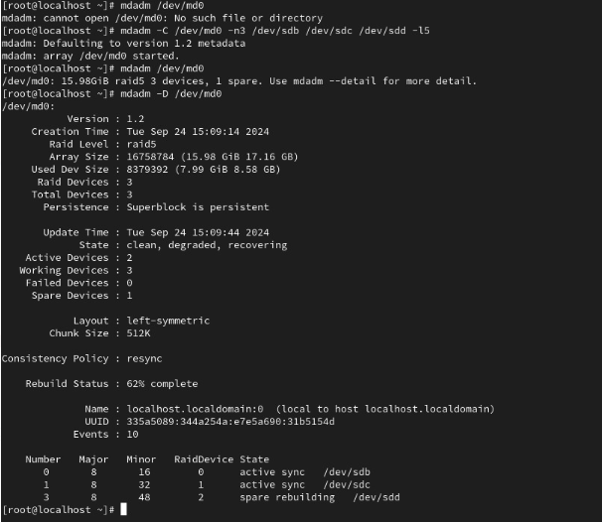

1. Mounting created R.A.I.D in a /raid folder

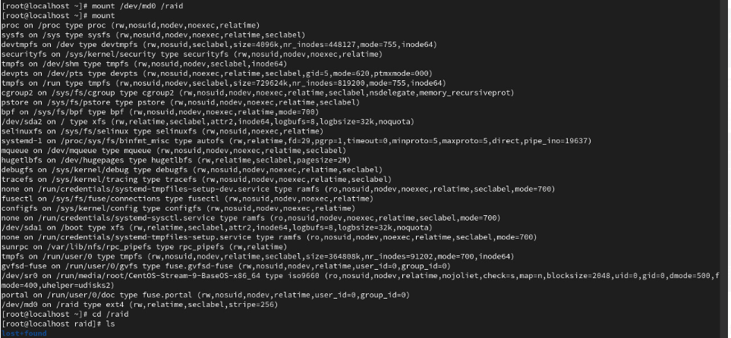

1. Runing commands in our creted R.A.I.D like

-f = faulty

-r = remove disk

-a = add disk

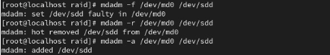

1. Unmounting R.A.I.D from /raid folder

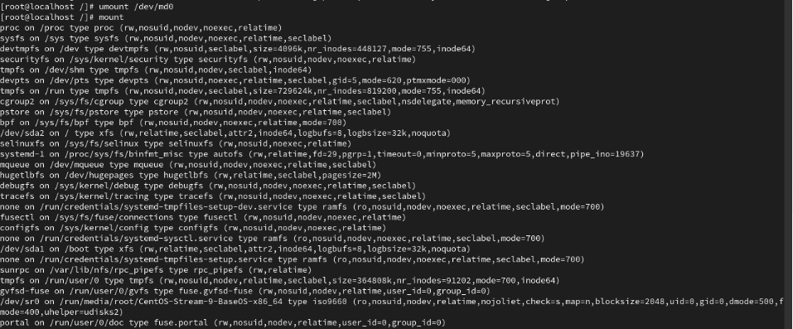

1. Runing few commands which were run only after unmounting like

-S = stop

-A = activate

